**MOTION IN TWO DIMENSIONS**

Motion in two dimensions can be modeled as two independent motions in each of the two perpendicular directions associated with the x and y axes. That is, any influence in the y direction does not affect the motion in the x direction and vice versa.

ROJECTILE MOTION

* the path is that of an inverted parabola, symmetric about a vertical line that passes thru the vertex (highest point)

Ex: A batted baseball, a thrown football, a package dropped from an airplane, and a

bullet shot from a rifle

* Projectile – any object launched into space without power of its own and is free to move under the action of gravity

* Trajectory – path followed by a projectile

* Range – horizontal displacement

**Projectile motion** is one type of two-dimensional motion under constant acceleration, where *ax=0* and *ay = g = -9.8m/s2*. It is useful to think of projectile motion as the superposition of two motions: (1) constant-velocity motion in the x-direction (vfx = vix = vx) and (2) free-fall motion in the vertical direction subject to a constant downward acceleration of magnitude g=9.80 m/s2.

Horizontally, the projectile exhibits constant-velocity motion: Its horizontal acceleration is zero, so it moves equal x-distances in equal time intervals.

Vertically, the projectile exhibits constant-acceleration motion in response to the earth’s gravitational pull. Thus, its vertical velocity changes by equal amounts during equal time intervals.

At the top of the trajectory, the projectile has zero vertical velocity (vy = 0), but its vertical acceleration is still -g

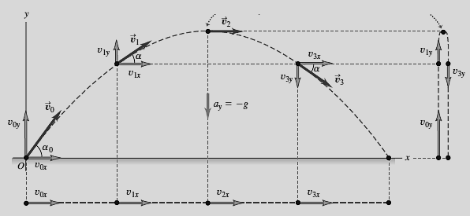

*Equations for Projectile Motion:*

Horizontal Component

$x=v_{x}t$

Vertical Component

let y = (+) if measured above reference point

(-) if measured below reference point

v = (+) if directed upward

(-) if directed downward

*vi = initial velocity

*vf = final velocity

$y=\left(\frac{v_{iy}+v_{fy}}{2}\right)t$

$v_{fy}=v_{iy}+gt$

$y=v_{iy}t+\frac{1}{2}gt^{2}$

${v_{fy}}^{2}={v_{iy}}^{2}+2gy$

*x and y components of Initial Velocity*

vfx = vx

vfy

vf

θ

vix

viy

vi

θ

$$v_{ix}=v_{x}=v_{i}cosθ$$

$$v_{iy}=v_{i}sinθ$$

*For Final Velocity*

$$v_{f}=\sqrt{{v_{x}}^{2}+{v_{fy}}^{2}}$$

$$θ=\tan^{-1}\left(\frac{v_{fy}}{v_{x}}\right)$$

CASE 1: *Projectile Fired Horizontally*

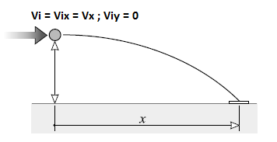

y

**vx**

**vf**

**vfy**

CASE 2: *Projectile Fired at an Angle Below the Horizontal*

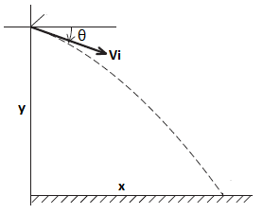

CASE 3: *Projectile Fired at an Angle Above the Horizontal*

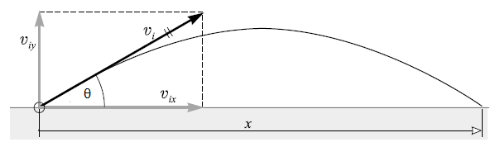

Vi

Sample Problems:

1. A projectile is fired horizontally with a speed of 30m/s from the top of a cliff 80m. (a) How long will it take to strike the level ground at the base of the cliff? (b) How far from the foot of the cliff will it strike? (c) With what velocity will it strike?
2. A body is projected downward at an angle of 30O with the horizontal from the top of a building 170m high. Its initial speed is 40m/s. (a) How long will it take before striking the ground? (b) How far from the foot of the building will it strike? (c) With what velocity (magnitude and direction) will it strike the ground?
3. A body projected upward from the level ground at an angle of 50O with the horizontal has an initial speed of 40m/s. (a)How long will it take to hit the ground? (b) How far from the starting point will it strike? (c) At what angle with the horizontal will it strike?